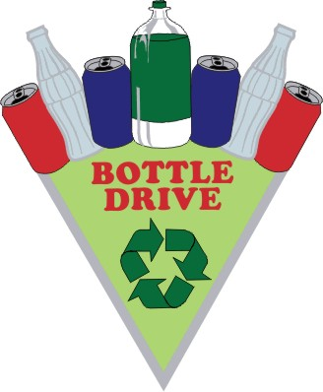

Ballenas Secondary School
Dry Grad 2016 Bottle Drive
Help us make the grad festivities memorable and safe!
When: Saturday January 9th, 2016
8:30am-4:00PM
135 North Pym Road, Parksville
For early pick-up, please contact Katrina at 250-248-9697 or email dahlstedts@shaw.ca
Thank you in advance for your support!

